Who to speak to if you are concerned about a child at Ormskirk Church of England Primary School

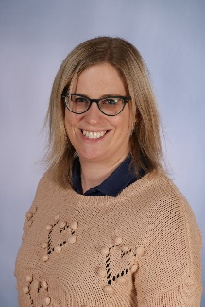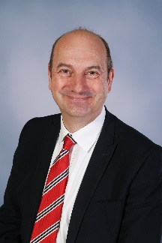
Mrs Rachel McBride
Nursery Phase Leader
Designated Safeguarding Lead (DSL)
r.mcbride@ormskirk-ce.lancs.sch.uk
Mr Giles Storch
Headteacher
Deputy Designated Safeguarding Lead

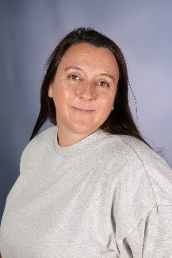
Mrs Heather Sheppey
SENDCo and Year 3/4 Phase Leader
Deputy Designated Safeguarding Lead
Mrs Liz Bull
Pastoral Teacher

You can report concerns using My Concern. All staff have their own log in.
Parents, visitors to the school or people hiring the school facilities should access this QR code to report safeguarding concerns.
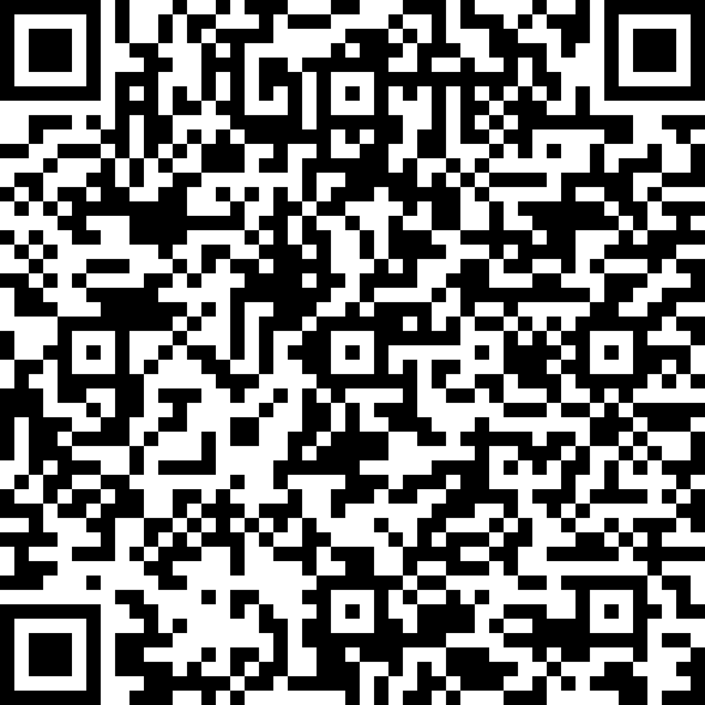
If you can’t use the QR Code, please access this link:
https://form.thesafeguardingcompany.com/1492a3c7-64c0-447c-8ea8-2c77863b6f4d
The DSL team will receive email notification of your report. For urgent incidents, please speak to a member of the DSL team immediately after submitting your concern. If a child is in danger, phone the police on 999.

Useful Numbers
Safeguarding Advice Line 01772 531 196
Multi Agency Safeguarding Hub (MASH) (9am-5pm) 0300 123 6720
Out of Hours Duty Team 0300123 6722
Local Area Designated Officer (LADO) 01772 536 694
NSPCC 0808 800 5000
If you think a child is in immediate danger, call the police on 999

